assignment #03

Course: CHE 433: Process Simulation with Aspen Plus
Term: Fall 2025
Professor: Dr. Michael Caracotsios
Office: EIB 244

Cell Phone: (630) 696-0934
E-mail: mcaracot@uic.edu

Student names: _______________________________________
Due Date: Friday November 21st , my office (3:00PM)

INSTRUCTIONS FOR ASSIGNMENT DELIVERY

- Prepare a typed report of your assignment.
- Include this cover page with your name(s) in the report.
- Upload your report as a PDF file by the Due Date and Time on the UIC Blackboard.
- Upload your Aspen Plus Simulation file (*.apw)
- Bring a hard copy of your report as a PDF file by the Due Date and Time in class

- Assignments that are not typed will not be accepted.
- Late Assignments will not be accepted without prior approval.
- You may use the Internet as well as ChatGPT or other public tools as long as you place a written statement about their use in your assignment report

Problem 1: Biomass Pyrolysis Simulation

Biomass conversion processes that are based on pyrolysis offer high yields of liquid transportation fuels such as gasoline and diesel blend stocks, or refinery intermediates. Fast pyrolysis proceeds by heating the biomass to an intermediate temperature where volatilization begins but the gasification of vapor-phase products does not occur. Fast pyrolysis generates a liquid bio-oil that can be transported efficiently and upgraded to fuels.

In a conceptual process design (see Process Flowsheet Diagram Figure 1. below), the fast pyrolysis reactor system is usually represented as a dual circulating fluidized bed. Biomass and hot sand are introduced into the bottom of a vertical riser reactor. As the solids are carried up the riser by a fluidizing gas, the rapid heating of biomass particles to around 450-500 degrees Celsius, produces non-condensable gases and vapors of oxygenated hydrocarbons. Unreacted biomass flows out as solid char. Solid and vapor phases exit the top of the riser and are separated in a cyclone. Sand and char drop into a char combustor, which is basically a second fluidized bed where the unreacted char is combusted in air to reheat the sand. The energy to drive the endothermic pyrolysis reactions is thus provided via the hot sand, by partial combustion of the biomass itself. The vapor phase is condensed downstream to form the bio-oil. In some cases, the bio-oil separates into organic and aqueous phases. Fast pyrolysis bio-oils can be as high as 50% oxygen by mass and are generally assumed to be hydro-treated downstream, to reduce oxygen.

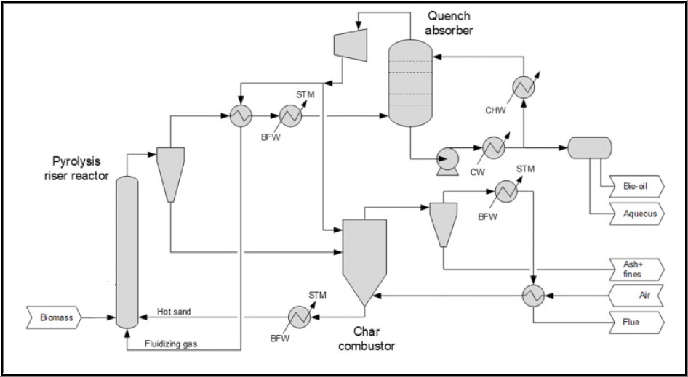

Figure 1: Process Flow Diagram(PFD) of Biomass Fast Pyrolysis

The objective of the assignment is to prepare an ASPEN Plus simulation and calculate:

- Total Power(KW) consumed
- Total High(250 ºC) and Low(125 ºC) pressure steam generated (MMSCFD)
- Mass yield (%) of incoming carbon to Bio-oil
- Mass yield (%) of incoming carbon to Flue Gas
- Mass yield (%) of incoming carbon to Waste Water

Your final report should also include the following

- Material and Energy Balance with the UIC template
- A brief outline of your methodology for modeling the pyrolysis reactor
- A brief outline of your methodology for modeling the char combustor

The Quench Absorber can be simulated using a SEP2 Aspen Plus Unit Operation block

Data for the simulation

- Bone dry biomass flow rate: 50,000 kg/hr
- Biomass feed temperature: 25 deg C
- Biomass feed pressure: 2.3 atm
- Moisture weight fraction: 0.1
- Fluidization gas to Sand mass ratio: 0.1
- Bleed Gas to Combustor: 13,000 kg/hr
- Bleed Gas temperature: 80 deg C
- Bleed Gas pressure: 2.31 atm
- Sand to dry biomass mass ratio: 7.0

- Biomass PROXANAL
  - Moisture:
  - Fixed Carbon (FC): 0.85*(100-ASH)
  - Volatile Matter (VM): 0.15*(100-ASH)
  - Ash (ASH): 0.3000
- Biomass ULTANAL
  - ASH: 0.30
  - CARBON: 49.66
  - HYDROGEN: 6.31
  - NITROGEN: 0.10
  - CHLORINE: 0.00
  - SULFUR: 0.08
  - OXYGEN: 43.55
- Biomass SULFANAL
  - PYRITIC: 0.00
  - SULFATE: 0.04
  - ORGANIC: 0.04

- Pyrolysis Reactor Pressure Drop: 0.3 atm
- Pyrolysis Reactor Temperature: 480 deg C
- Pyrolysis Reactor Yield (from Experiments)
  - Gas: 12.9%
    - H2: 0.10%
    - CO: 5.82%
    - CO2: 6.03%
    - CH4: 0.53%
    - C2H4: 0.42%
  - Water: 14.8%
  - Char: 9.7%
  - Organics: 62.6%
    - Acids[Acetic Acid]: 11.1%
    - Carbonyls[Acetone]: 12.7%
    - Phenols[m-Cresol]: 4.0%
    - Methoxyphenols[Guaiacol]: 27.5%
    - Levoglucosan: 4.4%
    - Furfural: 2.9%

- Combustor Pressure: 1.12 atm
- Combustion products: NO2, SO2, CO2, H2O
- Oxygen in the combustor effluent: 2% mol
- Fluidization Gas temperature: 375 deg C
- Fluidization Gas pressure: 2.31 atm
- Fluidization Gas and Bleed Gas composition, mol%
  - CO: 31.19
  - CO2: 20.11
  - Water: 15.09
  - NO2: 0.30
  - SO2: 0.91
  - Methane: 2.62
  - Ethylene: 1.51
  - Acetone: 28.27
- Sand component: SiO2
- Temperature of the Quench Absorber (SEP2): 45 deg C
- Pressure of the Quench Absorber: 1.7 atm

